Should be made in groups of max 6 students, handwritten, submitted on the next F2F session. Tardiness will cause a penalty of -5 per day. Distribute the homework within your group. Example: Ali will do number 1, Badu will do number 2, Charlie will do number 3, etc., and then staple your work together. Put your names and your sequential number on the first page. Do not put in my locker, it will be neglected.

- Find the value of limit below without using L’Hospital rule:
a. 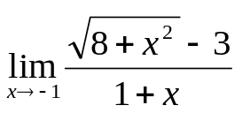 b. 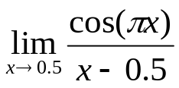
- Let 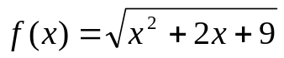 and 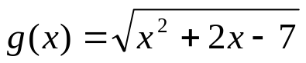. Both functions are continuous at x = a. Given that 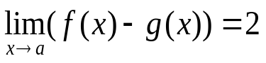, find 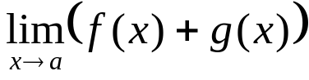 !
- If 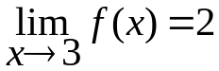 and 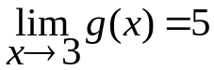 and g(x) is countinuous at x=3 then calculate 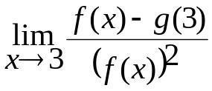.
- Find 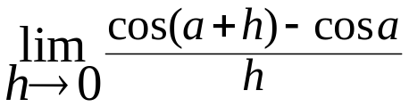
- Find 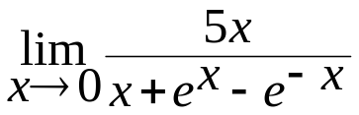
- Find 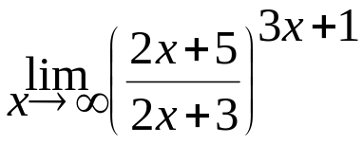
- Find the x values, if any, where the function is discontinuous
  - F(x) = x² + 3x +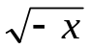
  - G(x) = 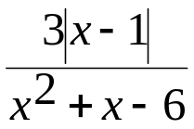
  - H(x) = 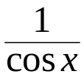
  - M(x) = 